Equipment required to complete the boom includes:

- Gorilla glue – polyurethane glue
- Water – preferably in a squirt bottle.
- Sharp Exacto knife
- Straight pins
- Rubber bands
- Flat working surface

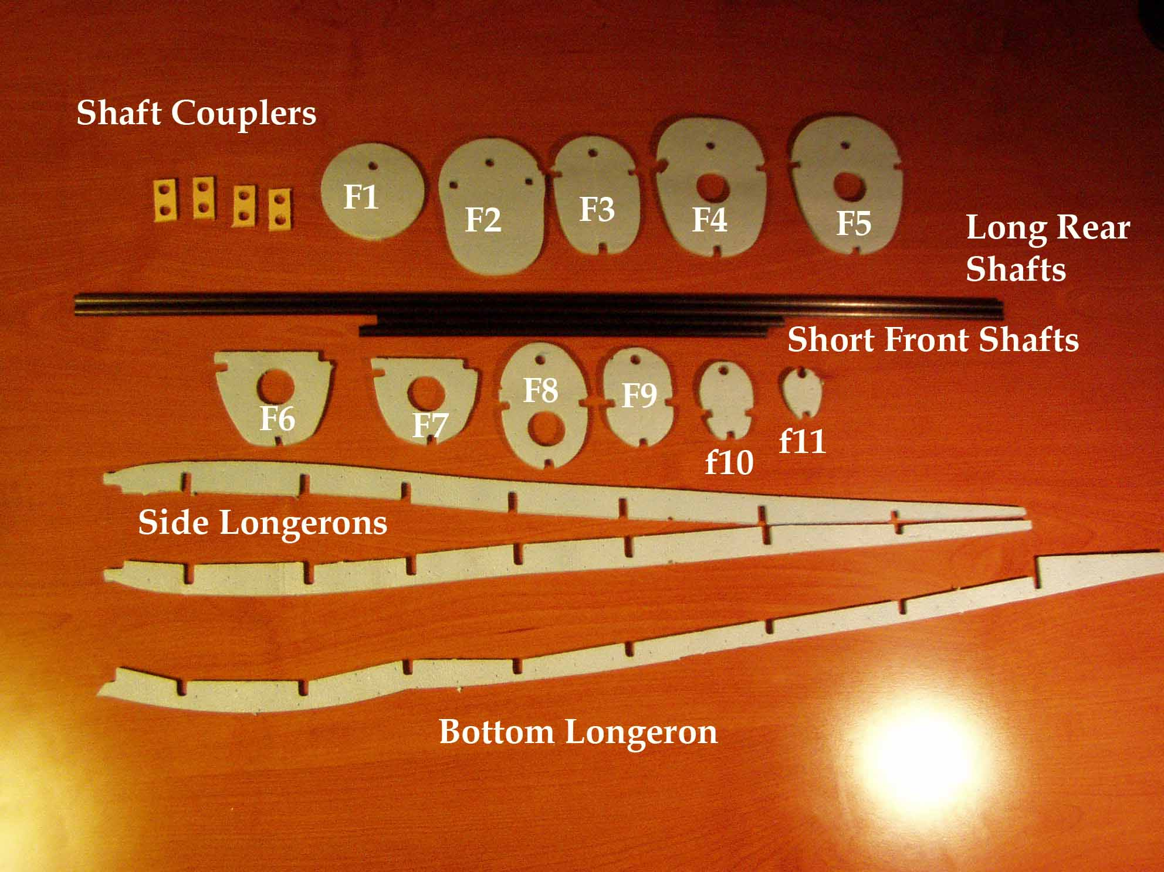

Punch out the parts for the boom and organize them to insure you have all the necessary parts. It is important that during the construction of the booms to 1.) test fit all the parts and secure with straight pins to insure the parts are in the correct spot. 2.) Do not glue the shafts or shaft couplers into place at this stage. 3.) Make sure you build one left and one right boom. The installation of F6 and F7 define a right or left boom.
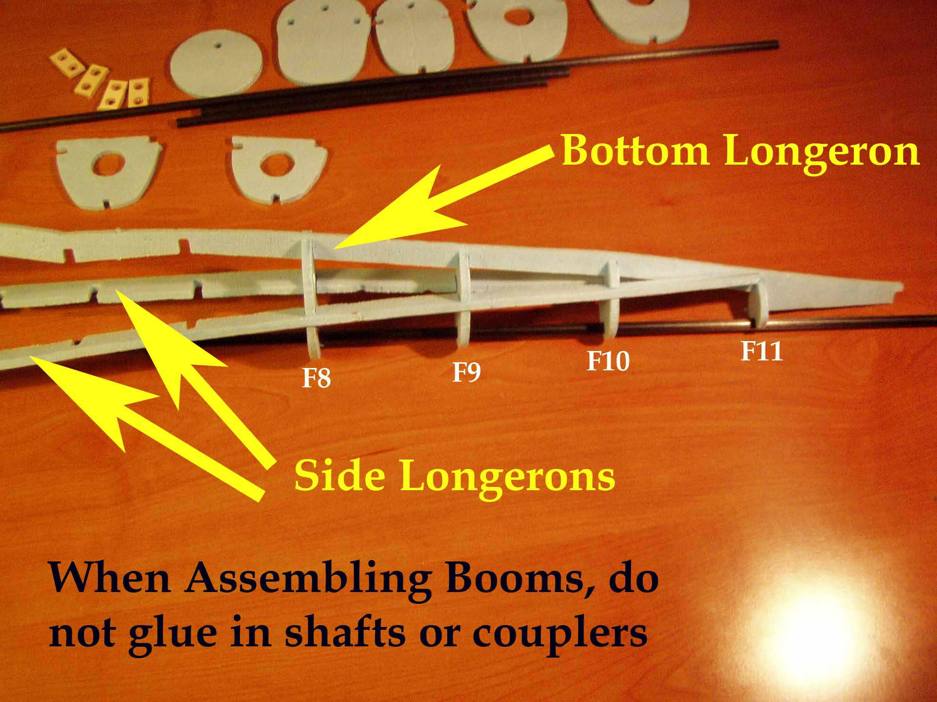
Slide formers F8, F9, F10 and F11 slide onto the rear boom shaft. The rear boom shaft is longer than the front boom shaft. Snap the side longerons into the slots in formers F8, F9, and F10. The side longerons rest against former F11. The assembly is upside down in the above photo.
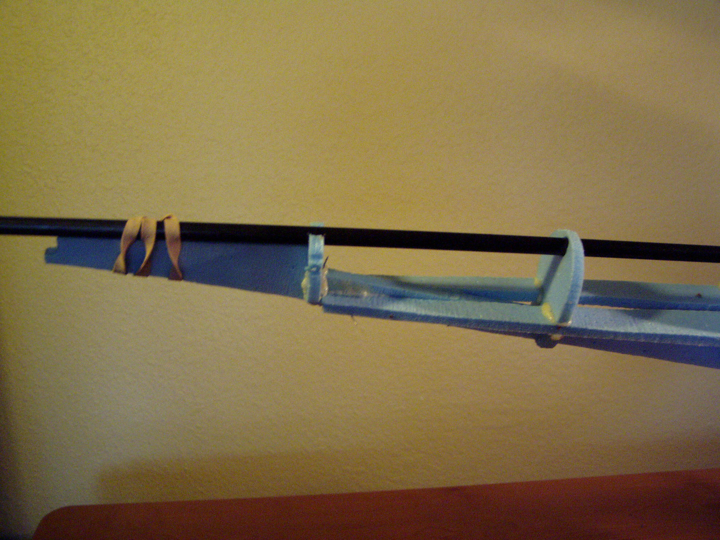

The slots for the side longerons are oriented toward the bottom of the formers as shown. Snap the bottom longeron into the bottom slots in formers F11, F10, F9, and F8. Use a rubber band to secure the bottom longeron to the rear boom shaft. No glue yet!

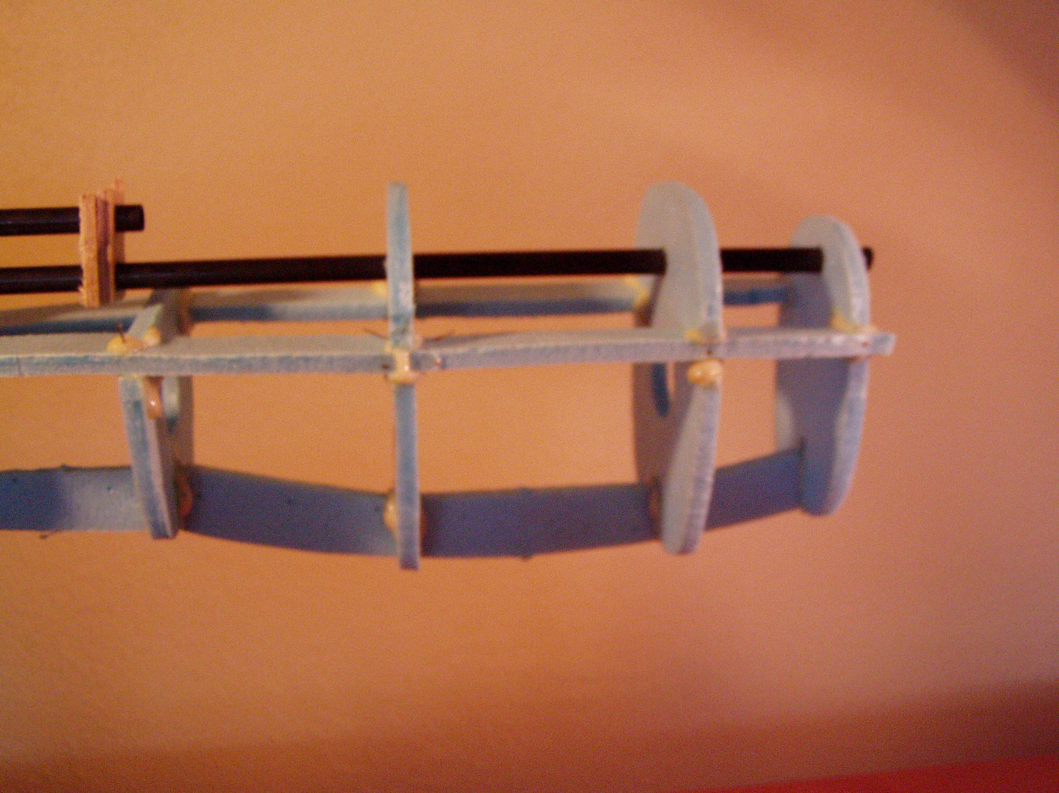
F1 and F2 are not used during this stage of construction- set them aside for now. Slide formers F3, F4 and F5 onto the front, shorter boom shaft.

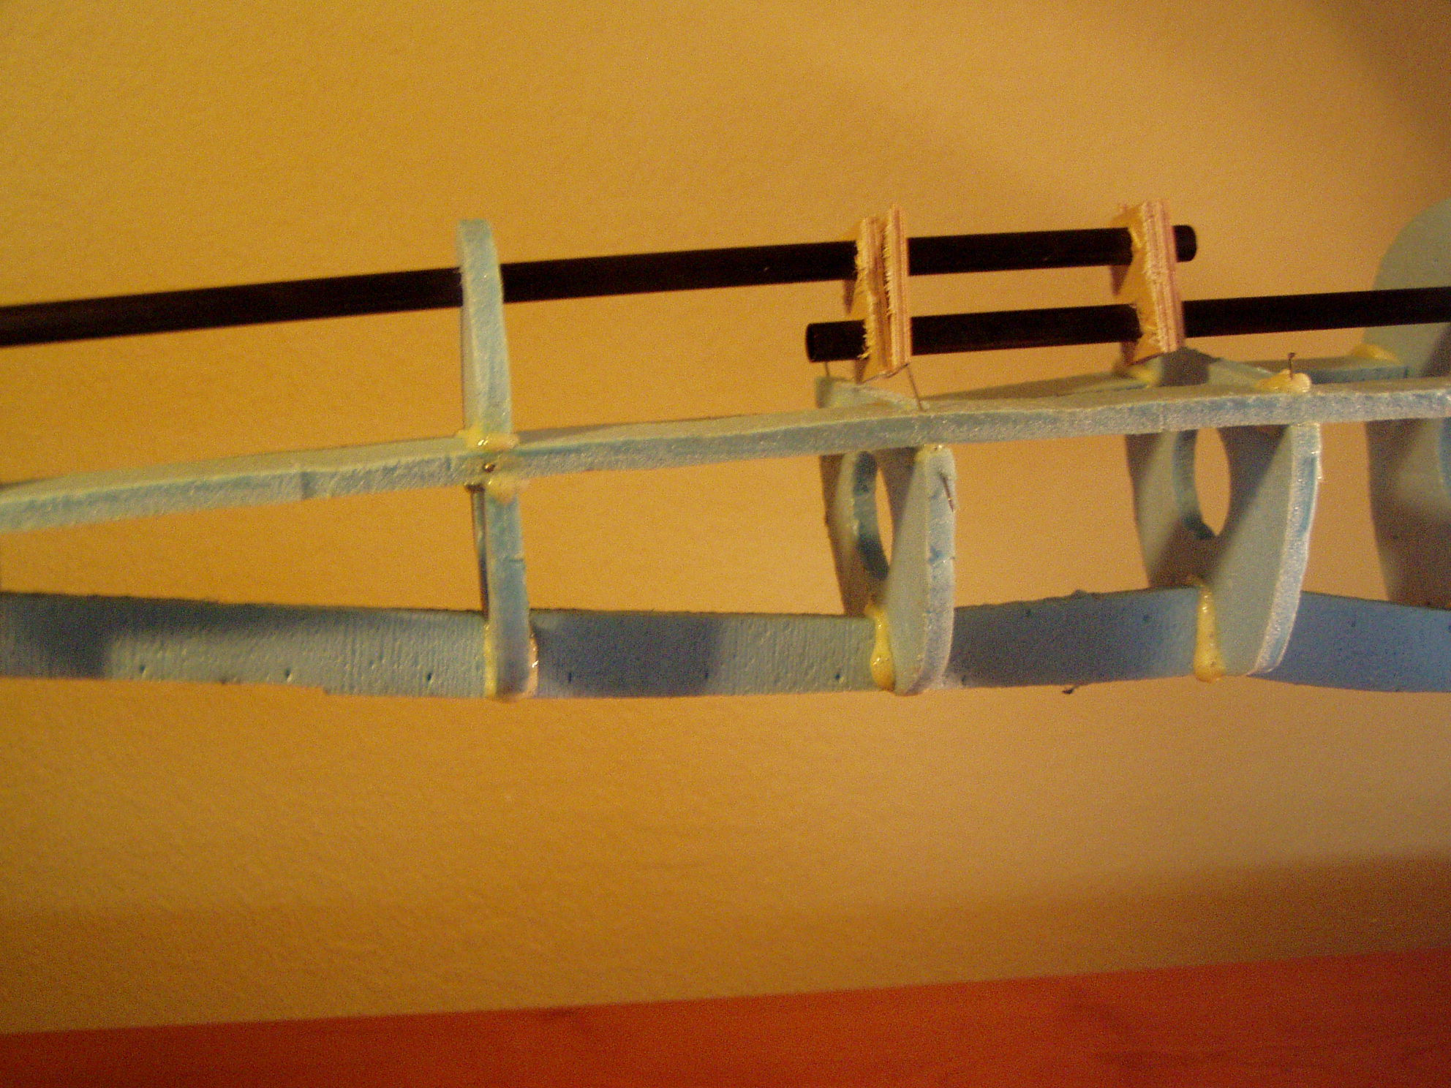
Use four shaft couplers to temporarily join the front and rear boom shafts. The front boom shaft is oriented below the rear boom shaft.
The alignment of the couplers is not important at this stage, as the shafts are not glued to the formers at this point.
Use the longerons to position former F3, F4 and F5 as in the previous photo.
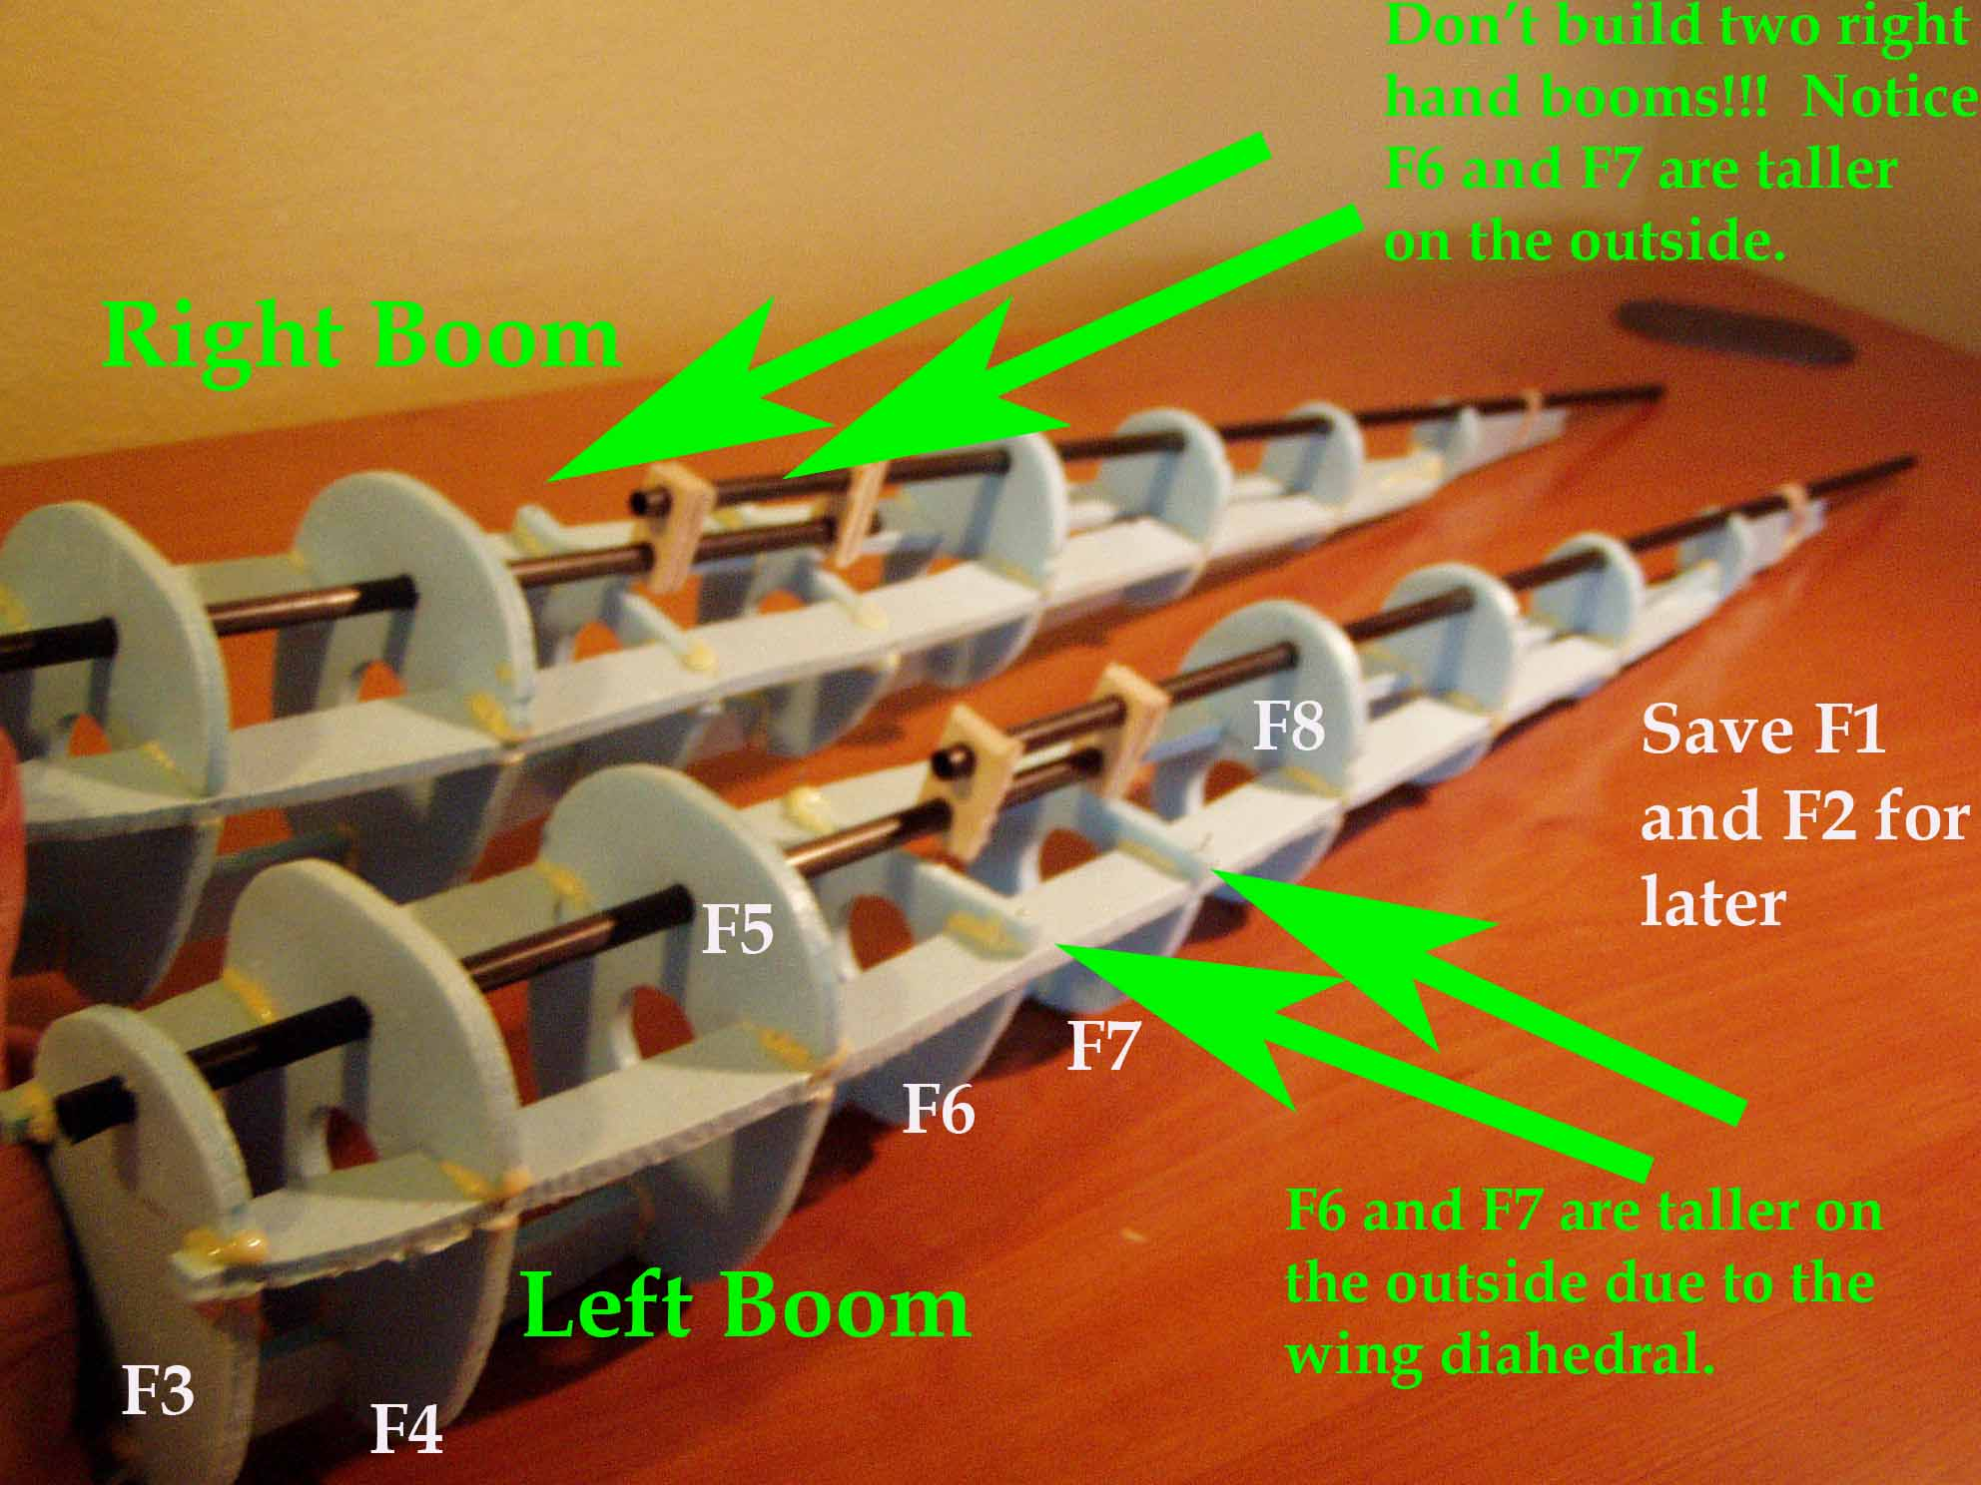
Snap formers F6 and F7 into place. These formers do not contact the boom shafts. It is recommended to build the two booms at the same time so to insure you build a left boom and a right boom.

Look at the picture and the way that the outside of the formers F6 and F7 rise above the side longeron. Sight down the booms from the front and rear and make sure the booms are true and straight. The longerons should be straight when viewed from the front. None of the formers should be twisted when viewed from the side.

Once you are happy with the fit and alignment of the parts glue the longerons to the formers. Agin, make sure you make one left boom and one right boom.

DO NOT GLUE THE SHAFTS TO THE FORMERS AT THIS POINT.
Close up of the coupler installation. Notice the straight pins holding the assembly together while the glue dries. I swear by Gorilla glue.

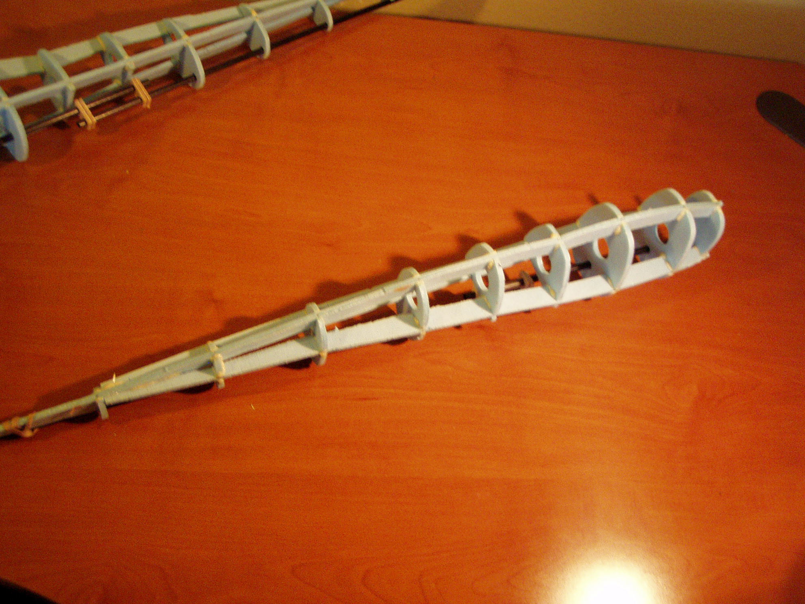
Sight down the booms and make sure the longerons are straight, then let the glue dry.
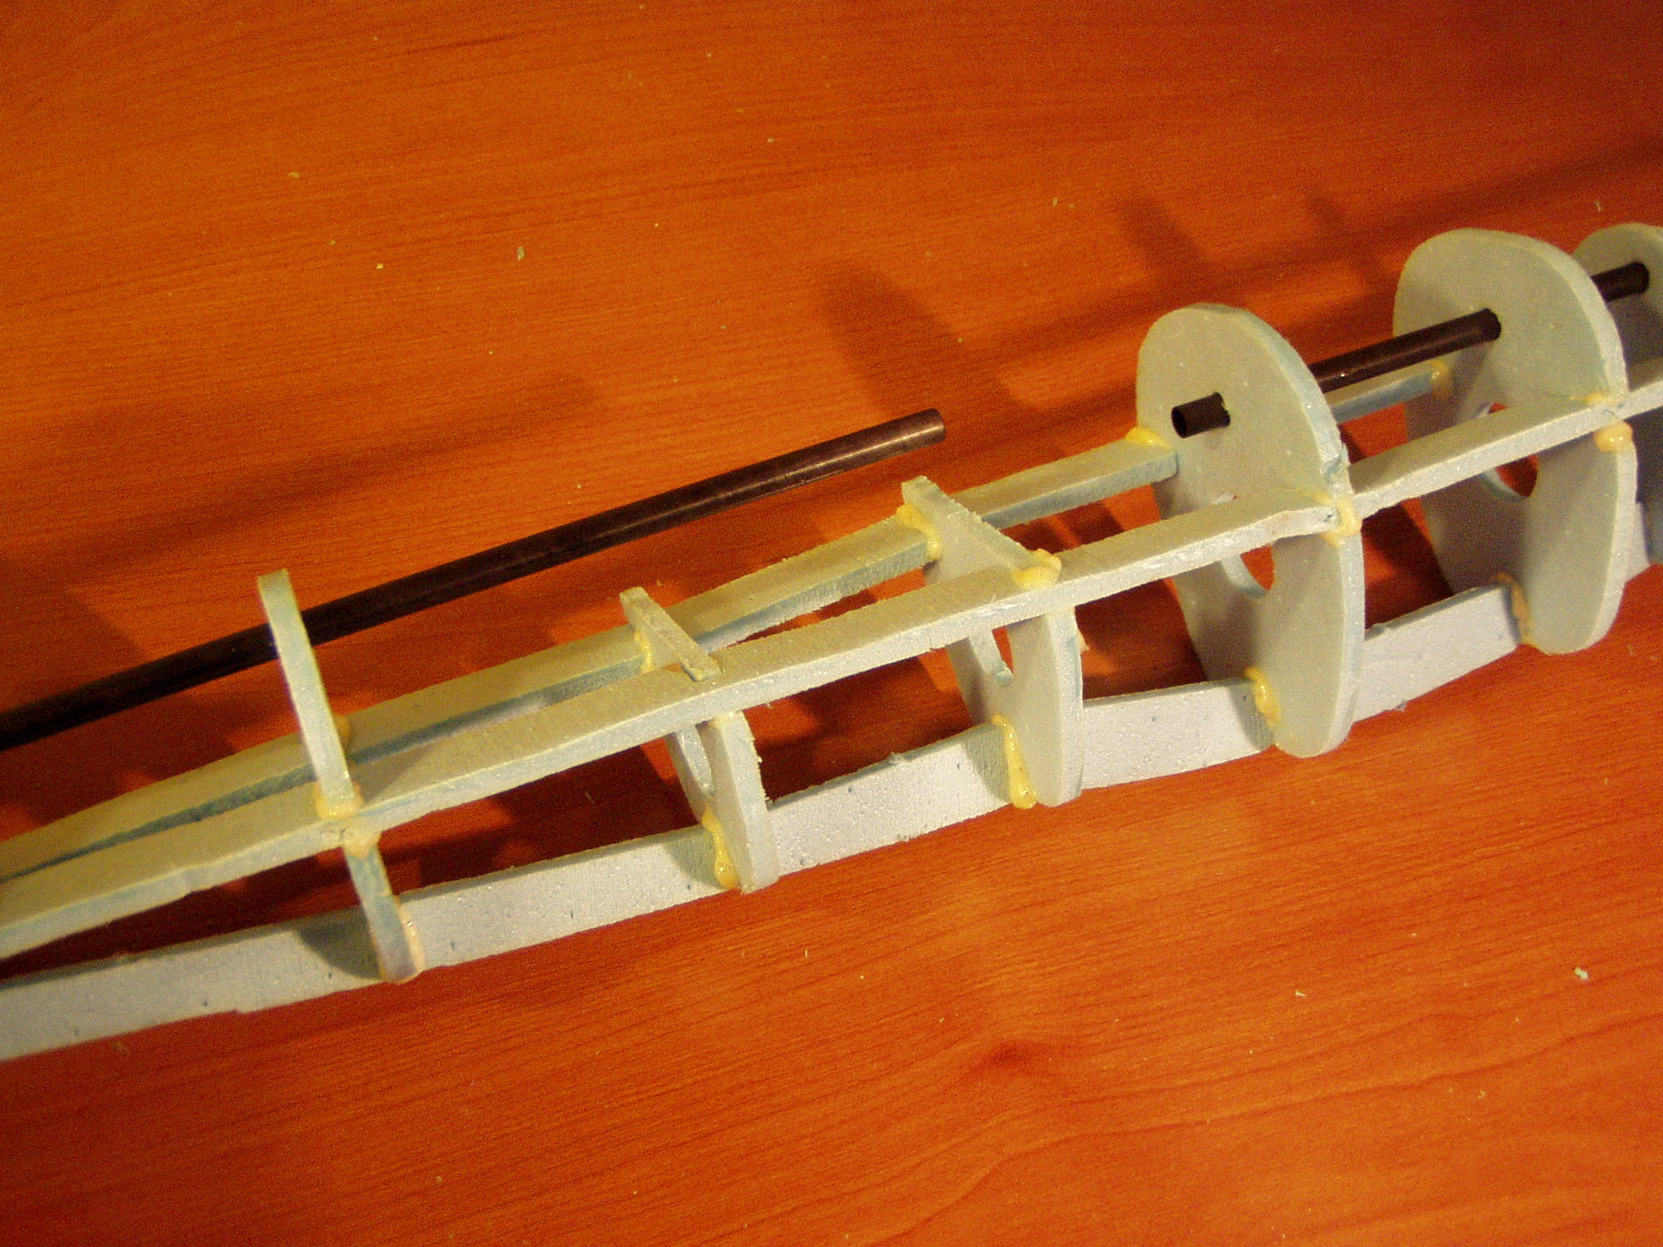
Once the glue has dried, remove the boom shafts.

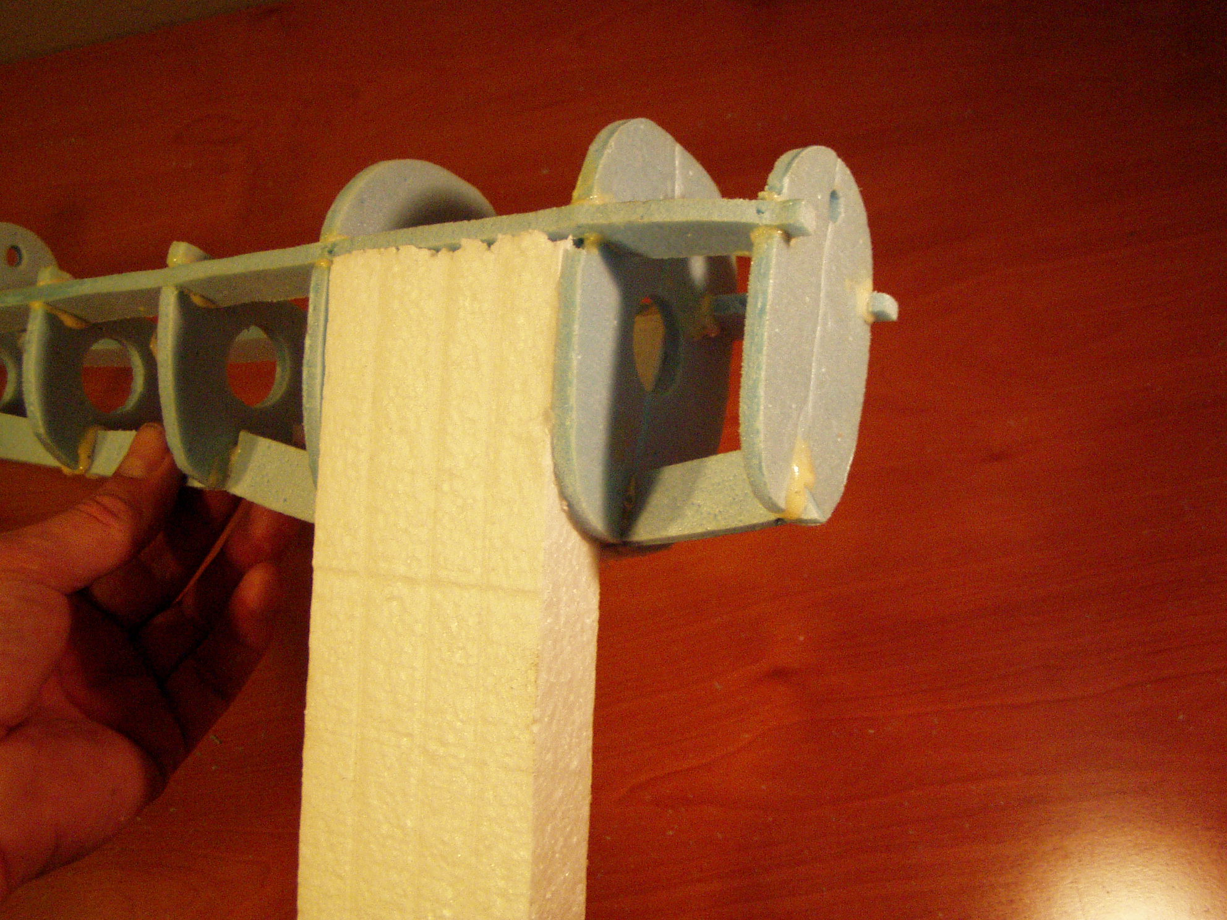
Use block Styrofoam between formers f4 and F5 as well as between F3 and F4. Refer to earlier pictures to identify the former numbers. Remember F1 and F2 have been set aside, so the forward most former is numbered F3 in the above photo.
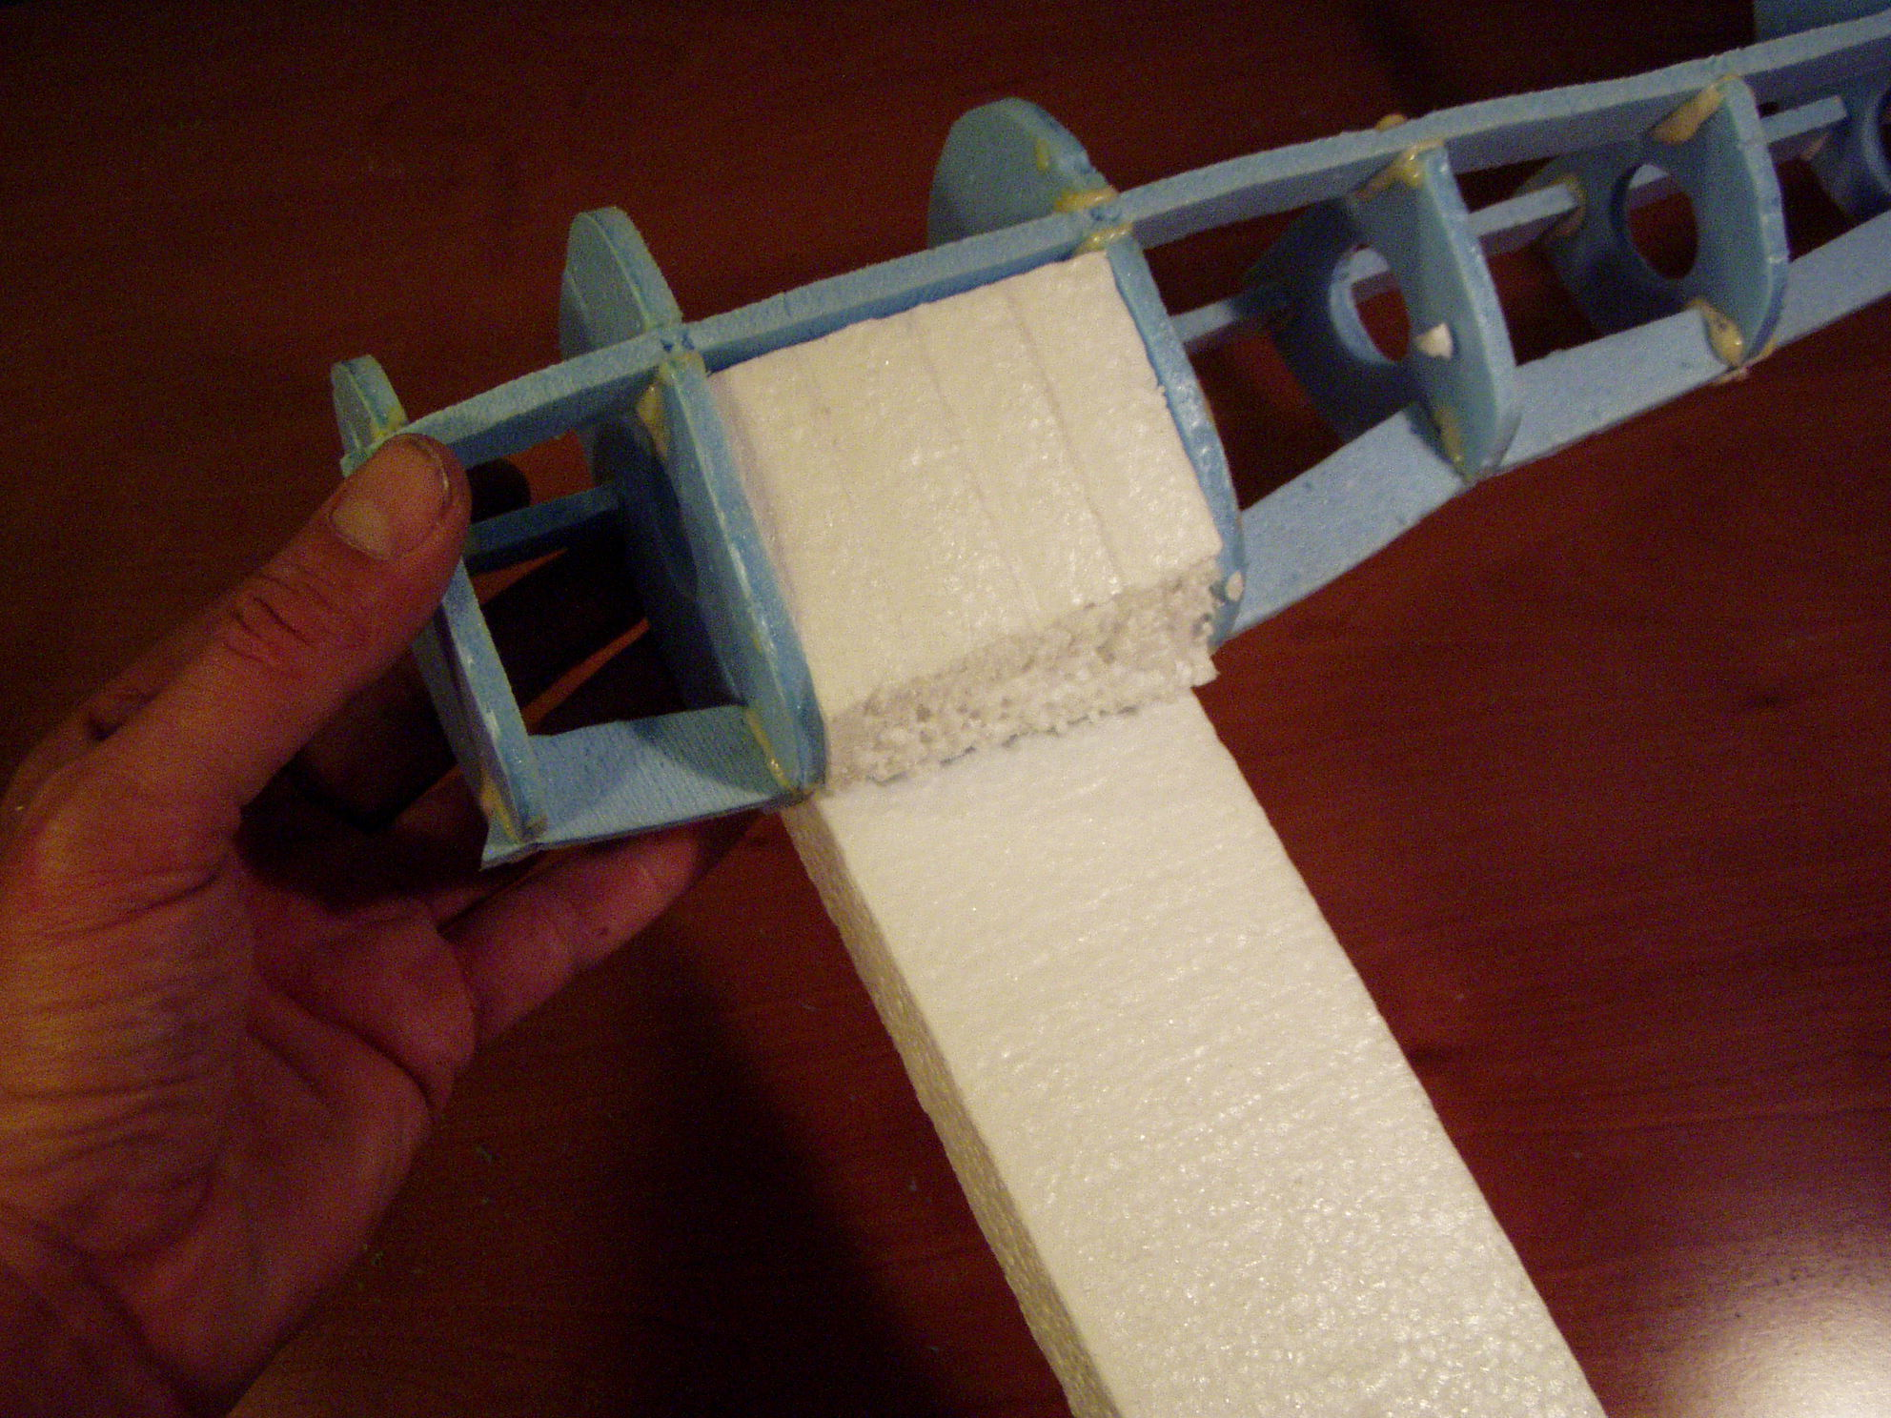
The Styrofoam installation does not have to be pretty as they are covered up with the skin--these blocks give rigidity for those rough landings.

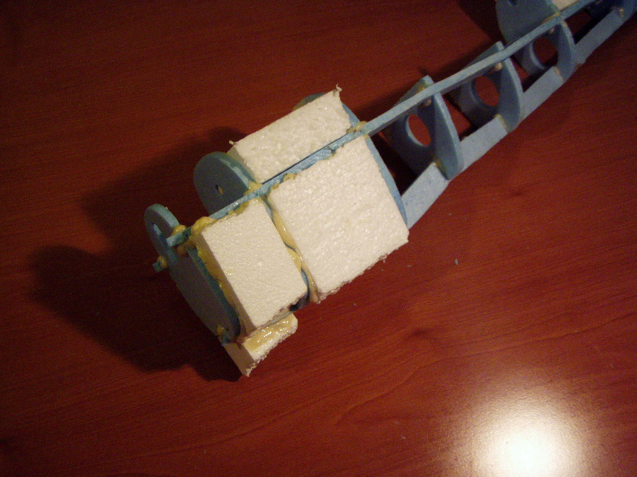
Between F3 and F4 foam block is installed below the side longeron. We will add a removable block above the longeron later.

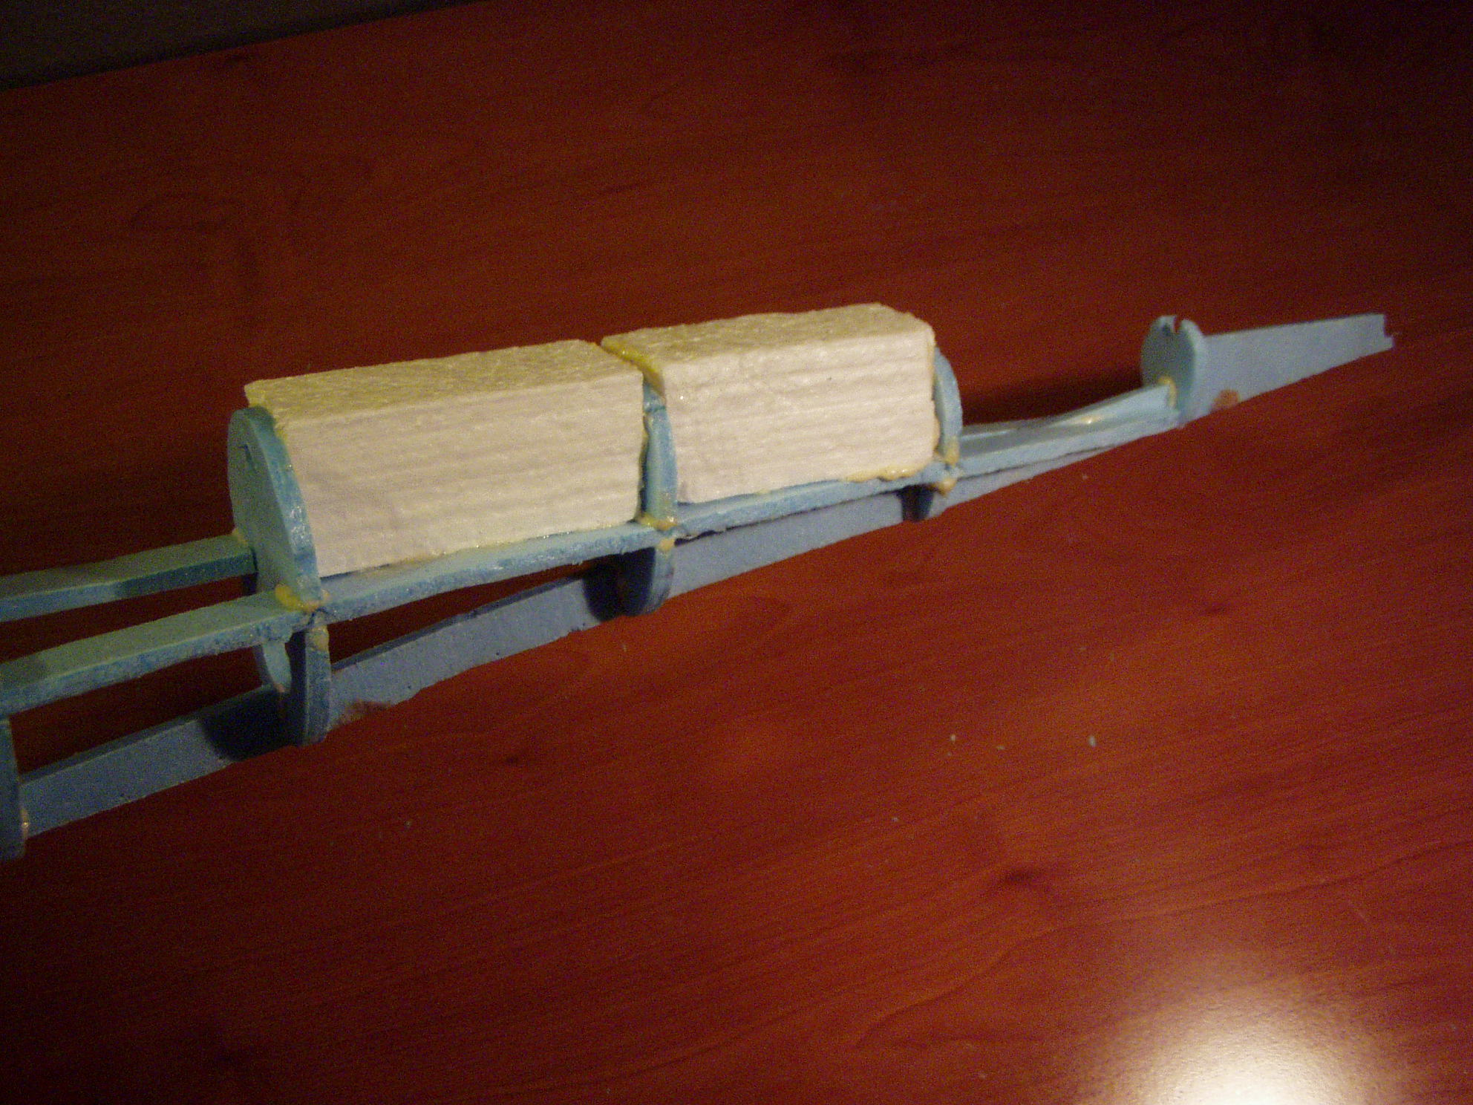
Install two Styrofoam blocks between F8 and F9 as well as between F9 and F10. The rear boom shaft will be forced through these later.

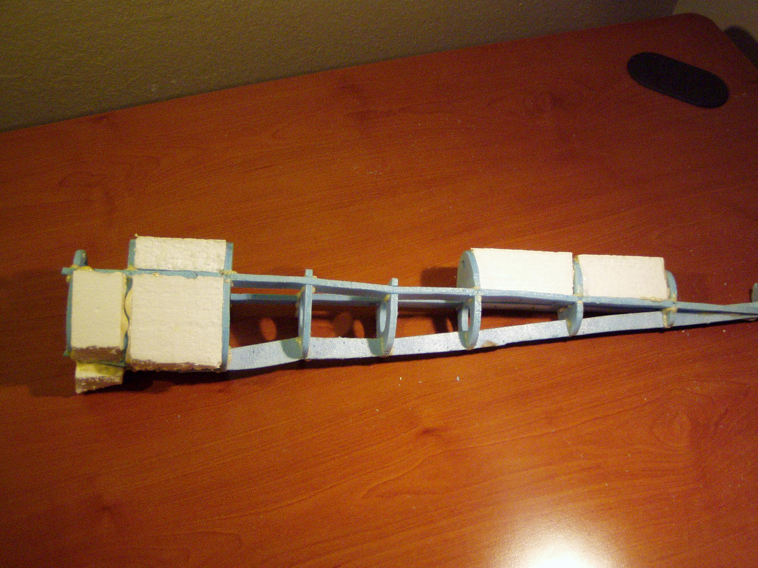
This is what the boom looks like before we rough shape the Styrofoam blocks.

Congratulations, the booms are assembled. It is time to move on to the wing assembly.

